FOR SALE
Used Car
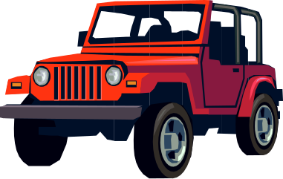

Bright Red 2003 Jeep Wrangler

- Very reliable vehicle - only 53,000 miles
- Four wheel drive great for going off-road
- Premium sound system, and leather interior
- Well worth the asking price of $15,500

For more details,
Please call 810-555-5156

